Chapter 11, Problem 63.

Find I_{o} in the circuit of Fig. 11.82.

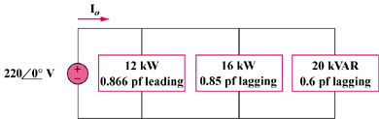

Figure 11.82
For Prob. 11.63.

